A report on

**Internship At “KSB Energy Pumps Division, Shirwal.”**

Submitted in partial fulfilment of the requirements for the degree of

# Bachelor of Technology

**in**

# Mechanical Engineering

Submitted by

**Mr. Shreyash Satish Killedar (19111005)**



**DEPARTMENT OF MECHANICAL ENGINEERING ANNASAHEB DANGE COLLEGE OF ENGINEERING AND TECHNOLOGY, ASHTA.**

**2022-23**

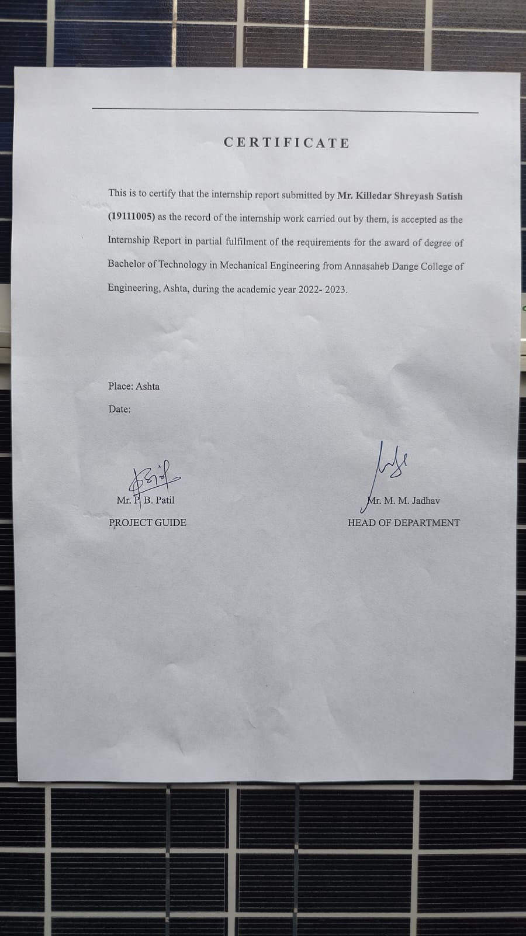

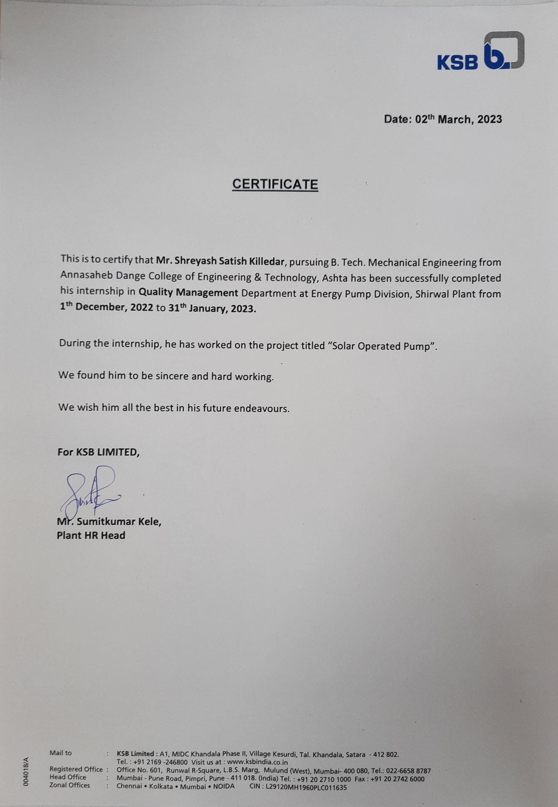

**Acknowledgement**

This internship undertaken by me in **KSB Energy Pumps Division, Shirwal** would not have been completed without support and guidance of many people. It is with immense pleasure that I acknowledge the contribution of all the concerned for their help and contribution in completion of my internship. First and foremost, I would like to express my deep respect and gratitude to the industry guide **Mr. Atul Mane** for their guidance and inputs which helped me understanding the various processes of the industry. I also thank the **Mr. Dhananjay Marathe [Manager- Quality Management].** for his support and for giving me this wonderful opportunity to complete my internship. It has been a wonderful opportunity and has helped in understanding the working and culture of the companies.

I next thank my internal- Institute guide from the institute **Prof. S. V. Nishandar** and **Prof. P.B. Patil** for his regular guidance and support which helped me to complete the internship. I am very much thankful to **Dr. Vikram. S. Patil**  Director, for allowing us on this internship. I also thank the **Prof. M. M. Jadhav** the Head of the Department of Mechanical Engineering of Annasaheb Dange College of Engineering and Technology, Ashta and all the other faculty and staff who directly or indirectly helped me in completion of my internship.

**Contents**

|  |  |  |
| --- | --- | --- |
| Sr. No. | Title | Page No. |
| 1 | About Company | 5 |
| 2 | Types & Application Of Pumps | 6 |
| 3 | What is Solar Energy ? | 13 |
| 4 | Types Of Solar Panel | 14 |
| 5 | Solar Panel Construction | 16 |
| 6 | Solar Cell Construction | 17 |
| 7 | Calculation of Solar For 10HP motor | 18 |
| 8 | Battery System & Invertor System | 20 |
| 9 | Approx Budget Of Solar Project | 21 |
| 10 | Payback Period | 23 |
| 11 | Conclusion | 24 |
| 12 | References | 25 |

**List Of Figures**

|  |  |  |
| --- | --- | --- |
| Sr. No. | Figure Title | Page No. |
| 1 | WKTB (Barrel pull out pump) | 6 |
| 2 | Industrial Water Treatment | 6 |
| 3 | RVR (Dry Installed Pump) | 7 |
| 4 | Waste Water Treatment | 7 |
| 5 | RSR (Dry Installed Pump) | 8 |
| 6 | Nuclear Power Plant | 8 |
| 7 | HG (Ring Section Pump) | 9 |
| 8 | Waste Water Treatment | 9 |
| 9 | CHTC (Dry Installed Pump) | 10 |
| 10 | Boiler Feed Water | 10 |
| 11 | FGD (Dry Installed Pump) | 11 |
| 12 | Industrial Power Plant | 11 |
| 13 | HDA Pump | 12 |
| 14 | Fire Fighting | 12 |
| 15 | Solar Panels | 13 |
| 16 | Monocrystalline Solar Panel | 14 |
| 17 | Polycrystalline Solar Panel | 15 |
| 18 | Thin Film | 15 |
| 19 | Solar Panel Construction | 16 |
| 20 | Solar Cell Construction | 17 |
| 21 | Cooling Tower Pump | 18 |
| 22 | 3PH induction motor | 18 |
| 23 | Invertor | 20 |
| 24 | Battery | 20 |

1. **About Company**

Excellent products and first-class service - this is KSB in India. KSB Limited, specialises in Centrifugal End Suction Pumps, High Pressure Multistage Pumps, Industrial Gate, Globe, Check Valves, Submersible Motor Pumps, monobloc & mini monobloc pumps and Hydropneumatic Systems.

A comprehensive range of KSB pumps and valves are manufactured from the facilities of KSB Pumps Limited spread over 6 centers in India... each facility dedicated to a product line. In-house design and manufacture of jigs, fixtures and dies under strict tolerances, ensure that the highest levels of quality are maintained., KSB in India has systematized concurrent production of dissimilar components. All components, each with different specifications, flow through the computer-controlled manufacturing process.

A systematized solution by KSB involves more than merely designing and building the right pump and valve to meet the exacting demands of a variety of customers.

All the pumps and valves are offered to the market through a very wide distribution network comprising of 4 zonal offices, 16 branches, over 800 authorized dealers, 6 service stations, over 200 authorized service centers and 22 godowns. KSB not only engineers state-of-the-art pump and valve technology but also strives to provide an air- tight array of service around pumps and valves.

At KSB, the relation with the customer is an ongoing partnership, continuing beyond product commissioning. Regular tailor-made training sessions are held, in-house and at the customers' sites, to acquaint them with selection, operation and maintenance to get the best from KSB pumps and valves. All this has been made possible by the commitment and dedication of the strong team who firmly believe that rewards come through the success of a client's project.

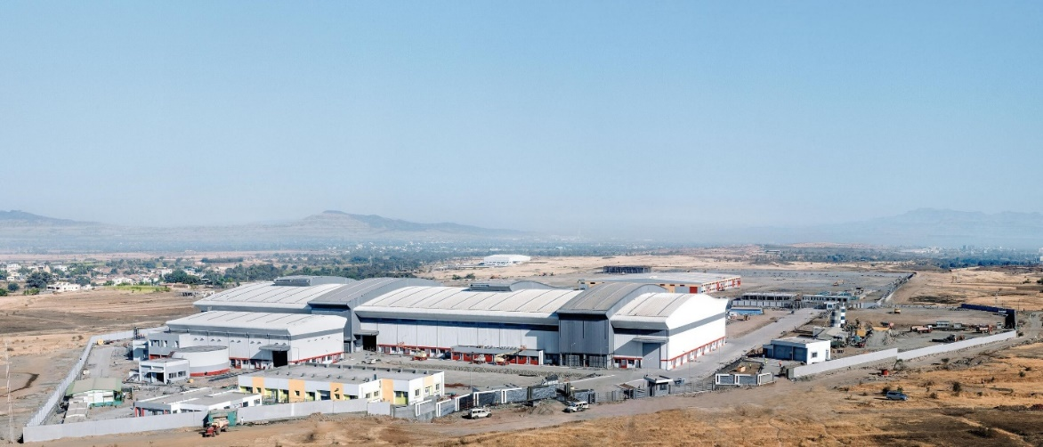

KSB Energy Pumps Division, Shirwal.

1. **Types & Application Of Pumps**

**1) WKTA/WKTB**

WKT/WKTB is a vertical radial split multistage ring section pump with mixed flow impeller. These pumps are used for condensate extraction and transfer applications in power plant up to 800 KW. It is a barrel pull-out ring-section pump for underground installation on a base frame in the pump sump, radial impellers, single-entry suction.

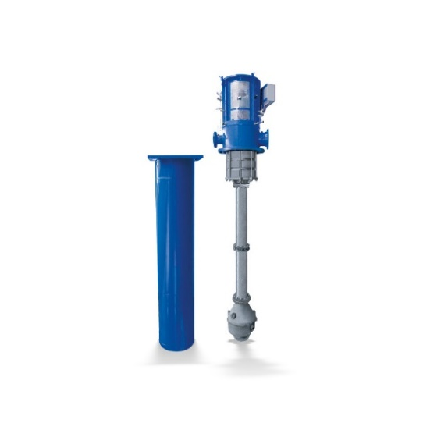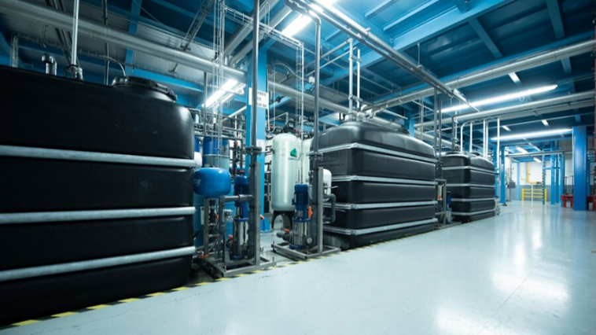

Fig.1 WKTB (Barrel pull out pump) Fig, 2 Industrial Water Treatment

Main Application:

Pumping condensate in power stations and industrial plants

Technical Data

Maximum Head: 370m

Minimum Head: 90m

Maximum allowed working pressure: 40bar

Maximum allowed fluid temperature: 100ºC

Maximum flow rate: 360m3/h

Maximum speed: 3600rpm

**2) RVRT 200-480**

Vertical shut down cooling pump suitable For Nuclear power project. Horizontal circular casing pump with forged or cast pressure boundary and diffuser. RVR Vertical circular casing pump with forged or cast pressure boundary and diffuser. RHR means horizontal circular casing pump with forged or cast pressure boundary and diffuser.

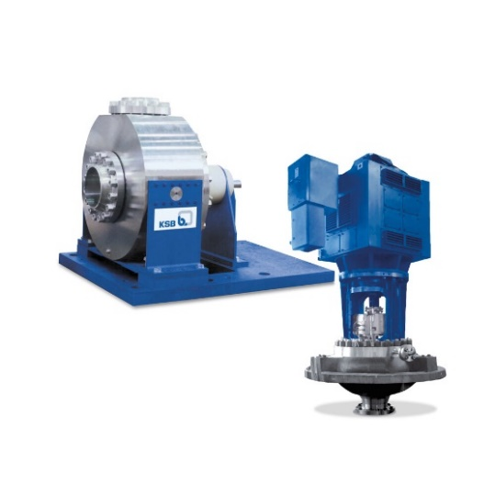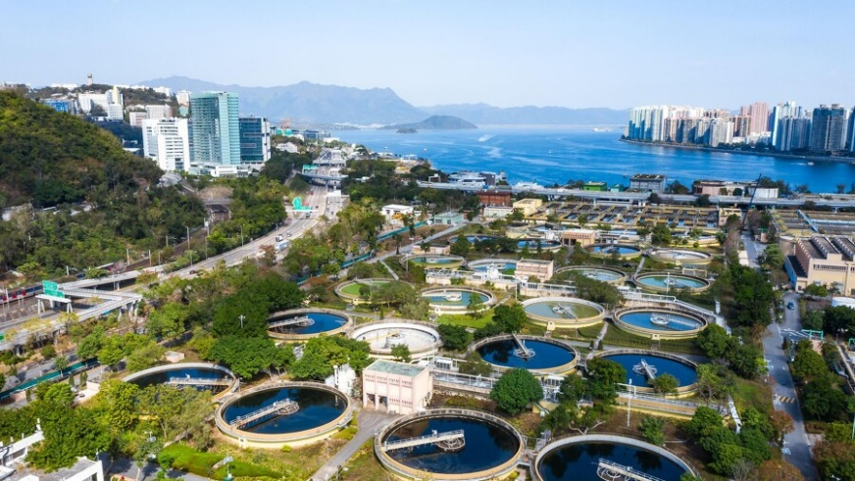

Fig.3 RVR (Dry Installed Pump) Fig. 4 Waste Water Treatment

Main Application:

The pump is used in core flooding, emergency cooling and residual heat.

Technical Data

Maximum Head: 190m

Maximum allowed working pressure: 63bar

Maximum allowed fluid temperature: 200ºC

Minimum allowed fluid temperature: 5ºC

Maximum flow rate: 6000 m3/h

Mains Frequency: 50Hz, 60Hz

**3) RSR 400/2.**

Primary cooling pump for Nuclear Project. Vertical single-stage reactor coolant pump with cast or forged casing, shaft supported by motor bearing.

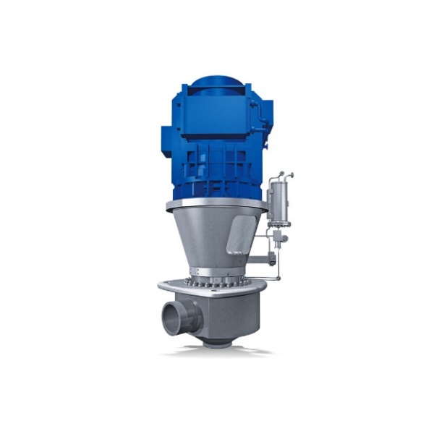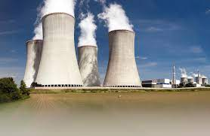Fig.5 RSR (Dry Installed Pump) Fig. 6 Nuclear Power Plant

Main Application:

The pump is used for nuclear project.

Technical Data

Maximum Head: 215m

Maximum allowed working pressure: 175bar

Maximum allowed fluid temperature: 350ºC

Minimum allowed fluid temperature: 5ºC

Maximum flow rate: 24000m3/h

Mains Frequency: 50Hz, 60Hz

**4) HG/HGB/HGC**

Horizontal, multi stage, centrifugal pump in ring section design with radial impeller suitable for boiler feed water for captive & combined cycle co-generation power plants. These pumps are available with delivered heads as high as 4200 meters and capacities of up to 1,450 cubic meters per hour. They can handle fluid temperatures as high as 200°C. The design has been optimized to ensure long, trouble-free service life and simplified maintenance procedures.

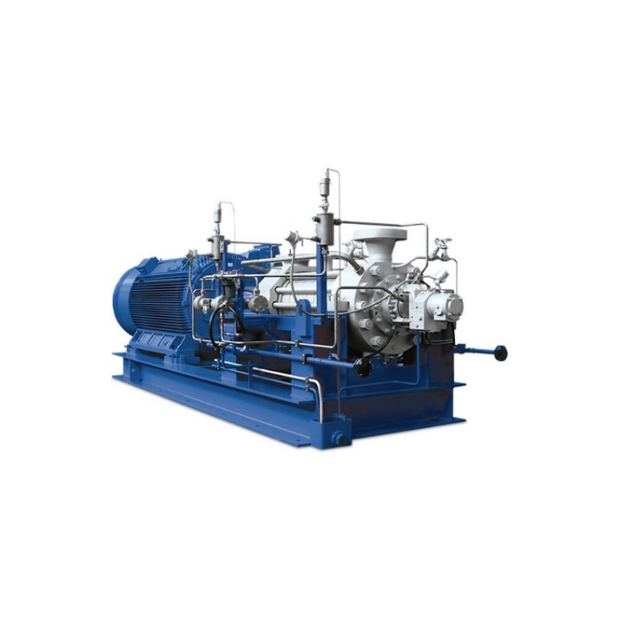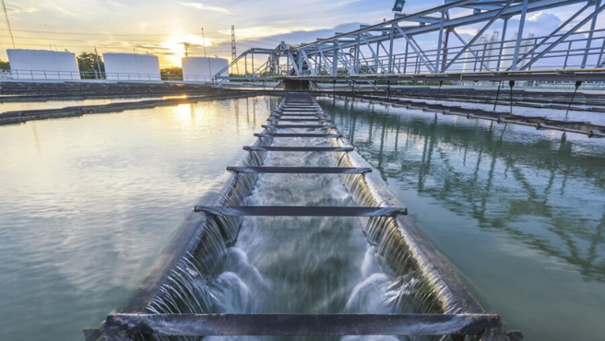

Fig.7 HG (Ring Section Pump) Fig. 8 Waste Water Treatment

Main Application:

Feed water in power stations, Boiler feed applications

Technical Data

Maximum Head: 4200m

Minimum Head: 140m

Maximum allowed working pressure: 420bar

Maximum allowed fluid temperature: 200ºC

Maximum flow rate: 1440m3/h

**5) CHTC/CHTR/CHTD**

Horizontal, multistage, bowel casing pump, suitable for boiler feed water a captive & combined cycle co-generation power plants I refinery applications. It is mainly used for condensate in power stations and industrial plant and generation of pressurized water for decaling units.

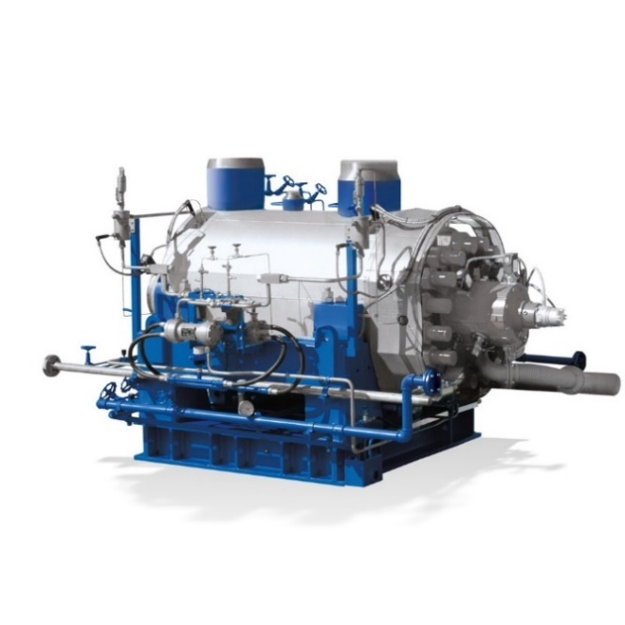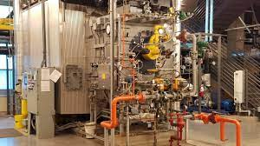

Fig 9 CHTC (Dry Installed Pump) Fig. 10 Boiler Feed Water

Main Application:

Pumping boiler feed water and condensate in power stations and industrial plants

Technical Data

Maximum Head: 4000m

Minimum Head: 0.1m

Maximum allowed working pressure: 400bar

Maximum allowed fluid temperature: 200ºC

Maximum flow rate: 1450m3/h

**6) FGD**

Slurry handling pump with single suction, low speed, high flow with special anti erosion coating. Flue-gas desulfurization (FGD) is a set of technologies used to remove sulfur dioxide (SO2) from exhaust flue gases of fossil-fuel power plants, and from the emissions of other sulfur oxide emitting processes such as waste incineration. KSB FGD Slurry pumps are High-flow/low-head hard metal pumps with a single-wall shell design, it have high-efficiency impeller, Suction-side liner is equipped with integrated mounting plates.

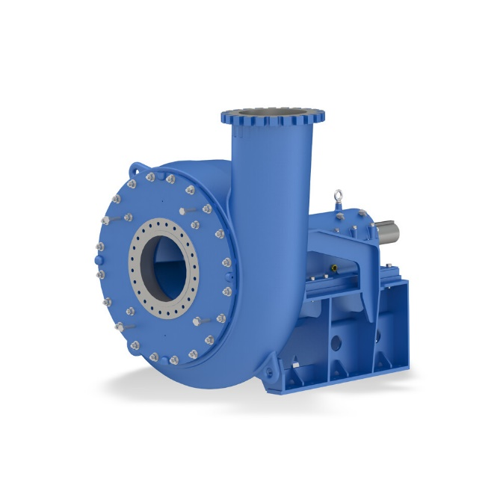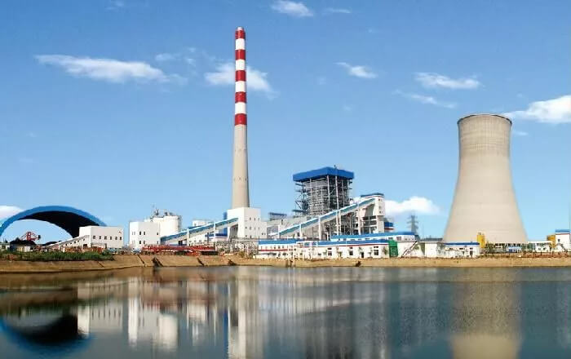

Fig.11 FGD (Dry Installed Pump) Fig. 12 Industrial Power Plant

Main Application:

It is used for remove sulfur dioxide from flue gases.

Technical Data

Maximum Head: 45m

Maximum allowed working pressure: 17bar

Maximum allowed fluid temperature: 120ºC

Maximum flow rate: 23000m3/h

**7) HDA**

Horizontal, radially split, ring section, high pressure multi-stage pump with radial impellers.

HDA is a high pressure multistage centrifugal pump. HDA pumps are mainly used as Boiler FeedPumps inindustry. They are also employed for high pressure hydraulic circuits viz. Hydraulic presses, decorticating, coke cutting, decaling and municipal water supply systems. These pumps are used extensively in core sector industries like power, chemical refinery, fertilizer and steel plants. Maximum flow rate of HDA pump is 576 m3/h and maximum head is 1450 m.

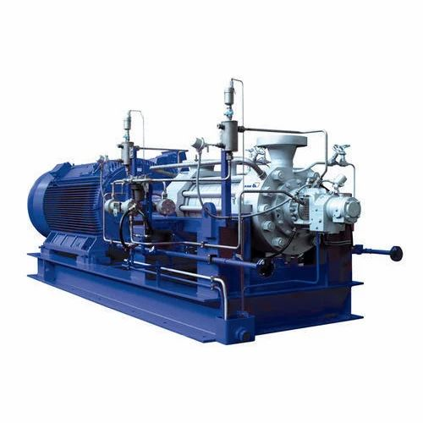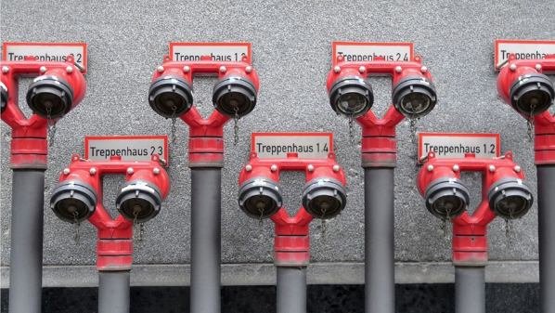

Fig. 13 HDA Pump Fig. 14 Fire Fighting

Main Application:

Suitable for water works, irrigation, sprinkler, installations, boiler-feed applications

Technical Data

Maximum Head: 1450m

Maximum Flow Rate: 576m3/Hr

Maximum allowed working pressure: 145bar

Maximum allowed fluid temperature: 200ºC

1. **What is Solar Energy ?**

Solar energy is the radiation from the Sun capable of producing heat, causing chemical reactions, or generating electricity. The total amount of solar energy received on Earth is vastly more than the world's current and anticipated energy requirements. If suitably harnessed, solar energy has the potential to satisfy all future energy needs.

The most common devices used to collect solar energy and convert it to thermal energy are flat-plate collectors. Another method of thermal energy conversion is found in solar ponds, which are bodies of salt water designed to collect and store solar energy. Solar radiation may also be converted directly into electricity by solar cells, or photovoltaic cells, or harnessed to cook food in specially designed solar ovens, which typically concentrate sunlight from over a wide area to a central point.

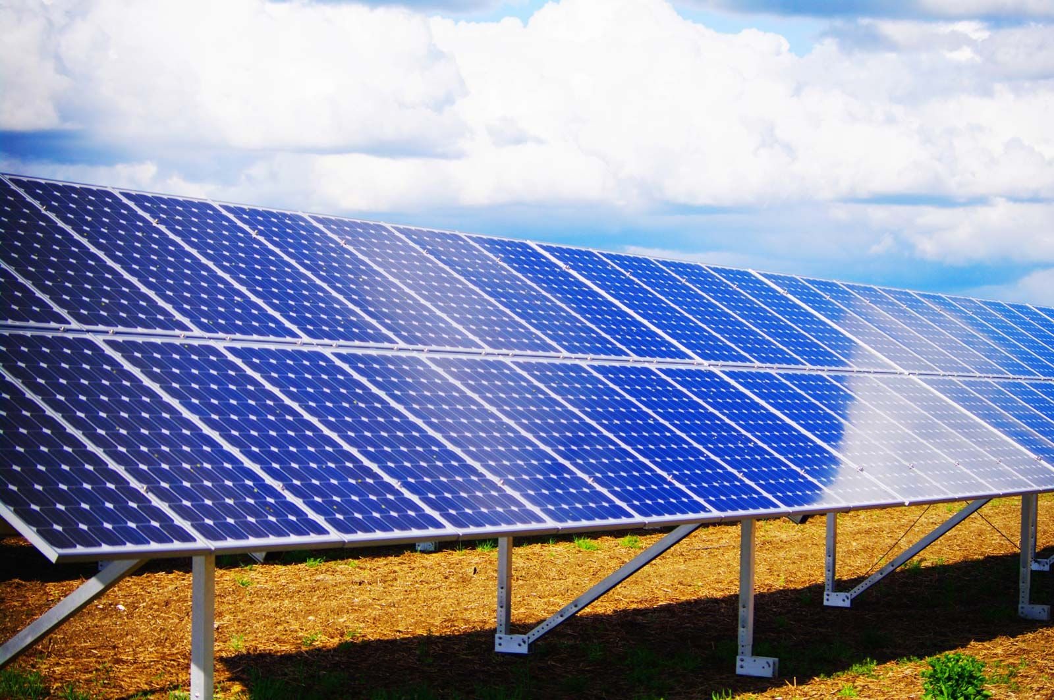

Fig. 15 Solar Panels

1. **Types of Solar Panels**
2. **Monocrystalline**

Monocrystalline solar panels are the most popular solar panels used in rooftop solar panel installations today.

Monocrystalline silicon solar cells are manufactured using something called the Czochralski method, in which a 'seed' crystal of silicon is placed into a molten vat of pure silicon at a high temperature.

This process forms a single silicon crystal, called an ingot, that is sliced into thin silicon wafers which are then used in the solar modules.

[Bificial](https://www.solarreviews.com/blog/bifacial-solar-panels) Solar Panels another monocrystalline technology, can generate electricity on both the front and back side of a module, and are gaining traction in commercial ground-mounted applications.

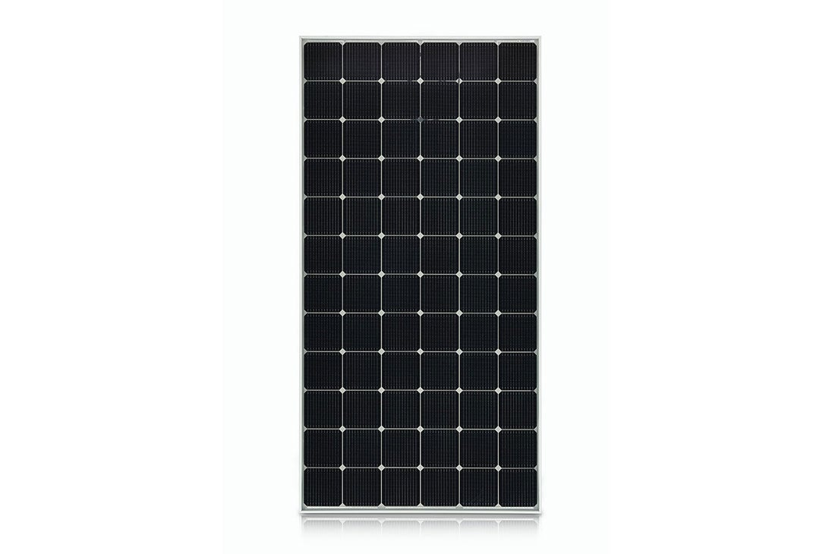

Fig.16 Monocrystalline Solar Panel

1. **Polycrystalline**

**Polycrystalline panels, sometimes referred to as ‘multicrystalline panels’, are popular among homeowners looking to install solar panels on a budget**.

Similar to monocrystalline panels, polycrystalline panels are made of silicon solar cells. However, the cooling process is different, which causes multiple crystals to form, as opposed to one.

Polycrystalline panels used on residential homes usually contain 60 solar cells.

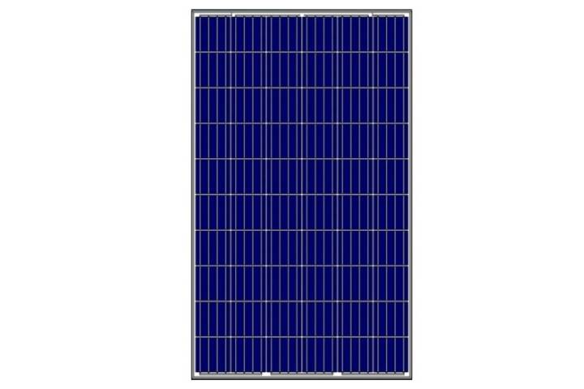

Fig.17 Polycrystalline Solar Panel

1. **Thin Film**

Thin film solar panels are made by depositing a thin layer of a photovoltaic substance onto a solid surface, like glass. Some of these photovoltaic substances include Amorphous silicon (a-Si), copper indium gallium selenide (CIGS), and cadmium telluride (CdTe)

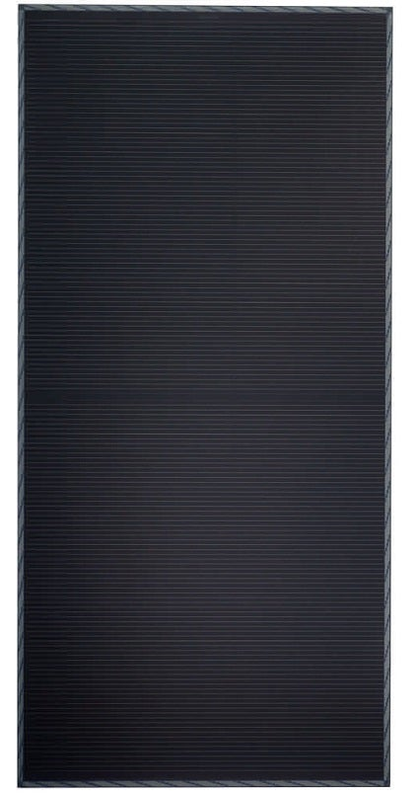

Fig.18 Thin Film

1. **Solar Panel Construction**

Solar panel technology is advancing rapidly with greater efficiency and lower prices resulting in a huge increase in demand. However, despite the massive advancements in technology, basic solar panel construction hasn’t changed much over the years. Most solar panels are still made up of a series of **silicon crystalline cells** sandwiched between a front glass plate and a rear polymer plastic back-sheet supported within an aluminium frame.

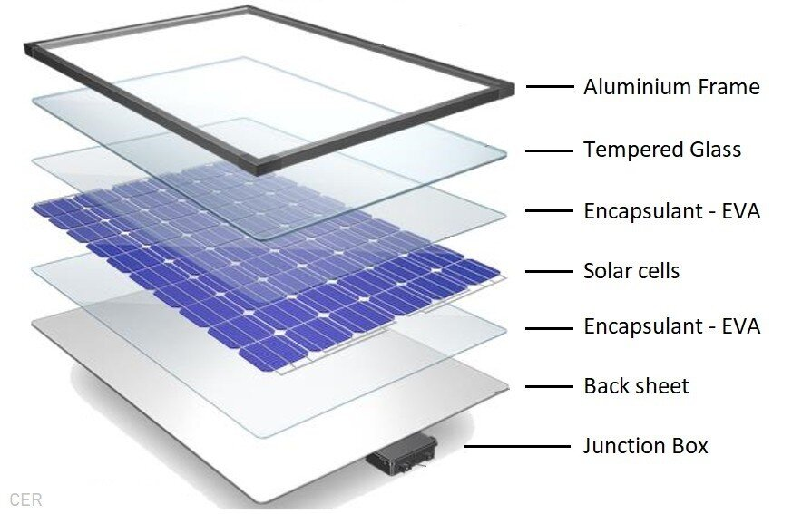

Fig. 19 Solar Panel Layers

**How Solar Panels Made ?**

Solar panels are made using the six main components described in detail below and assembled in advanced manufacturing facilities with extreme accuracy.

Six main Components:

1. Solar photovoltaic cells
2. Toughened Glass - 3 to 3.5mm thick
3. Extruded Aluminium frame
4. Encapsulation - EVA film layers
5. Polymer rear back-sheet
6. Junction box - diodes and connectors

**6. Solar Cell Construction**

Silicon is generally manufactured from a specific type of sand known as [silica sand](https://www.selectsands.com/what-is-silica-sand/) which is usually made from crushed quartz rock and contains a high percentage of a natural compound called Silica or silicon dioxide (SiO2). A number of different manufacturing processes are required to make crystalline silicon solar cells starting from the raw material quartz rock or Quartzite.

First, the silica sand is converted into [metallurgical grade silicon](https://en.wikipedia.org/wiki/Silicon#Alloys) by combining Carbon and Quartzite in an arc furnace. This process occurs at very high temperatures and results in 99% pure silicon. Next, the metallurgical grade silicon is converted into Polysilicon using either a chemical purification process called the [Siemens process](https://en.wikipedia.org/wiki/Siemens_process), or upgraded metallurgical-grade silicon (UMG-Si) using a number of more economical metallurgical processes. At this stage, the metallurgical-grade polysilicon can be **doped** with trace amounts of either boron or phosphorous to become either [P-type or N-type](https://www.cleanenergyreviews.info/blog/solar-pv-cell-construction) polysilicon.

To make polycrystalline wafers, the doped silicon is melted and cast into large rectangular blocks before being thinly sliced using a diamond wire cutter to produce the **polycrystalline** or **multi-crystalline** wafers. The wafers can then be coated with a very thin layer of either P or N-type to form the [PN-junction](https://www.pveducation.org/pvcdrom/pn-junctions/formation-of-a-pn-junction) (photovoltaic cell)

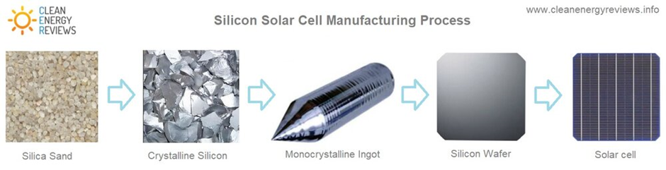

Fig. 20 Solar Cell Construction

**7. Calculation of Solar For 10HP Motor**

**Pump Information**

Cooling water pumps (CWP) provide the fresh water to cool the exhaust steam in the condenser and pump it back to the wet cooling tower or the outlet of open cooling system. The major characteristic of the CWP is their high flow.

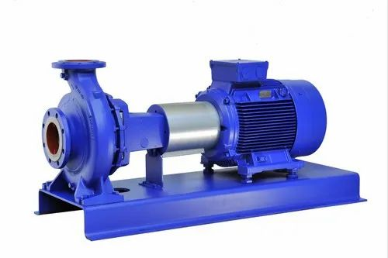

Fig. 21 Cooling Tower Pump

**Motor Information**

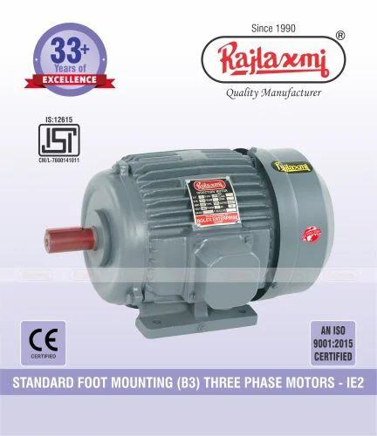3PH Induction Motor

Machine No: 7.5k6

RPM: 970

Kw(Hp): 7.5 Kw(10Hp)

Volt: 415±10%

Amp: 15

Ref. No: QIAM0960

Frame: ND160M

Efficiency: 89.1%

Fig. 22 3PH Induction Motor

1. The Motor is Working for 4Hrs in 1 day. So the power required for 1 day is 7.5×4=30kwhr.
2. The Power Required for 1 month is,

30×30= 900kwhr

1. 1 Solar panel generates 300watts average power in 1 hr.

We have need of 7500w of power in 1 hr.

7500/300= 25 Solar Panels (Approx.) Required

1. So, 25 solar panels generates 7500kw energy in 1 hr
2. In normal days we absorb 3-4 hrs energy from sun.

Means 7500×4= 30000watts of energy collect from the sun per day and we use 15000watts of energy per day and other energy can be stored in the batteries.

1. Average Dimensions of Solar Panel is 2.2m×1.05m×0.035m
2. Monocrystalline Solar Panels are best solar panels because, it has highest efficiency than other solar panels.
3. Angle of Solar Panel: 25º to 30º is best angle for solar panels for sufficient sunlight.

**8. Battery System & Invertor System**

1. One 150Ah battery can store 1600watts of average energy.

So we have required almost 10 batteries of 150AH .

1. The dimension of 1 Battery is 0.502m×0.191m×0.44m
2. Alfa + 10 KVA MPPT Solar PCU invertor can be required for 10Hp motor.
3. PCU is a Solar Power Conditioning Unit (PCU) which uses Solar energy (primary) and also the power from grid (secondary), to charge the batteries as well as to feed to connected load.
4. Microtek MPPT BASED SOLAR PCU is designed to utilize maximum use of Solar Energy. If there is excess of Solar Energy Generation from PV then it charges the Battery and simultaneously it supplies the Power to the Load. While a solar PCU is similar to a solar inverter, there are a few differences.

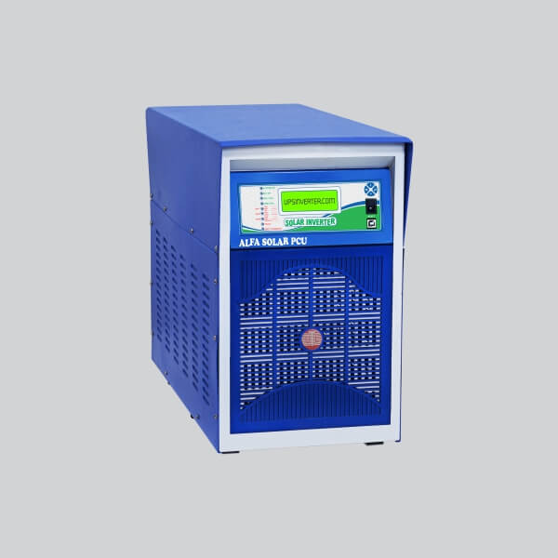

Fig.23 Invertor Fig. 24 Battery

**9. Approx Budget Of Solar Project**

1. Solar Panels

Average price of 1 solar panel is 15000rs (Bi-Ficial Solar Panels)

For 25 solar panels 13000×25= 325000Rs

1. Solar Panel GI structure (Galvanised Iron Structure)

For High Height 2500Rs

For Low Height 1500Rs

So Average Price for GI structure is 5000Rs for 7.5kw motor solar system.

1. Battery

Average price of 1 Battery of 150Ah is 12000Rs

For 10 Batteries 12000×10= 120000Rs

1. Invertor

Alfa + 10 KVA MPPT solar PCU

Price Of Invertor is 90000Rs

1. DC wires

6mm DC wire= Rs80/m

10mm DC wire= Rs135/m

1. MC4 Connectors

Average 50Rs for 1 connector

2 in 1 out & 3 in 1 out

1. DCDB box & ACDB box

Used for the connecting the wires

DCDB box= 5000Rs

ACDB box= 3000Rs

1. LA & Earthing (For Safety from Thunderstorm)

1 LA (Lightning Arrestor) For 2000Rs

3 Earthing: 1 for Lightning Arrestor

1 for Solar panel

1 for Motor & Lights

1. Installation Cost

Average 20000Rs For installation.

|  |  |  |
| --- | --- | --- |
| Sr. No. | Components | Cost  (in Rs.) |
| 1 | Solar Panels | 325000 |
| 2 | Solar GI structure | 5000 |
| 3 | Battery | 120000 |
| 4 | Invertor | 90000 |
| 5 | All Accessories | 30000 |
| 6 | Installation | 20000 |
|  | Total Cost (Approx.) | 590000 |

Table. Total Approx Budget

1. **Payback Period**
2. Electricity required for 1 month is 900kwhr.

So, Electricity bill for 1 month is 900×6= 5400Rs

And Electricity Bill For 1 Year is 5400×12= 64800Rs

1. Payback Period Of Solar System is,

Payback Period = Cost of Solar Panels / Electricity Savings Per Year

= 590000 / 64800

= 9 Years (Maximum)

1. **Conclusion**

Solar pumping system offers an alternate means to meet the electricity demand for irrigation and livestock watering. Under the circumstances of inadequate supply of electrical energy, the solar water pump can play a significant role. The solar system has potentially high initial system cost, but it gives more benefit in long time. When we installed solar system then there is low labour and maintenance costs. No fuel requirement for solar project. It can be easy to remove, transport, and store. It has reliable and long life. The solar systems are Non-polluting. When we installed that solar system then there are other electric components also worked on the solar.

1. **References**
2. [www.solarwater.com](http://www.solarwater.com)
3. [www.pvsolarpump.com](http://www.pvsolarpump.com)
4. [www.tradeindia.com/solar-water-pumping-system](http://www.tradeindia.com/solar-water-pumping-system)
5. [www.builditsolar.com/WaterPumping/waterpumping](http://www.builditsolar.com/WaterPumping/waterpumping)
6. www.leonics.com/Solar Photovoltaic Systems
7. [www.solardyne.com/solwatpum](http://www.solardyne.com/solwatpum)
8. [www.geda.org.in/solar](http://www.geda.org.in/solar)
9. [www.indiawaterportal.org](http://www.indiawaterportal.org)
10. [www.cleanenergyriview.com](http://www.cleanenergyriview.com)

**GEO TAG PHOTOS IN INDUSTRY**

